4. Close Year

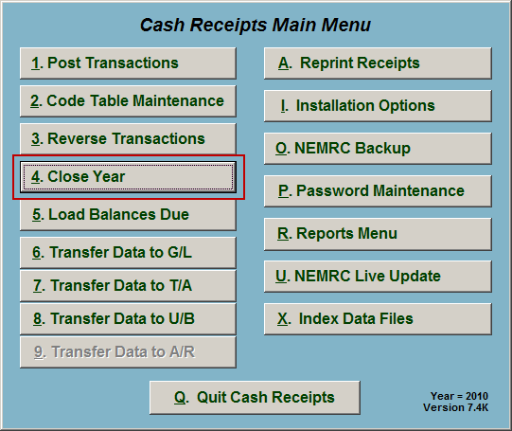
Click on “4. Close Year” from the Main Menu and the following window will appear:

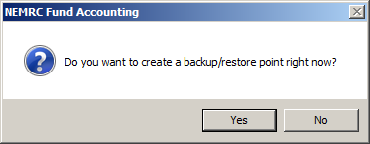
You should choose “Yes” to create a restore point. It may take a few minutes, and you will be notified when the restore point was created successfully. The following window will appear:

Close Year

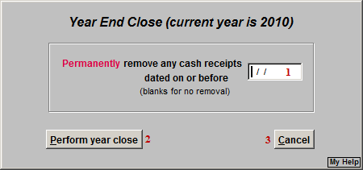
- Permanently remove..: Enter a date if you wish to Permanently remove any cash receipts dated on or before this date. Leave blank if you do not wish to remove any.

- Perform year close: Click this button to Perform year close.

- Cancel: Click “Cancel” to cancel and return to the Main Menu.

